Name: ___________________________

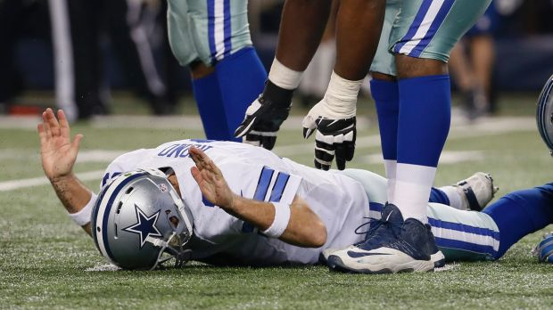
Caption Practice

Who: Tony Romo
When: Sunday Janurary 4
What: Scores touchdown to bring team in the lead
Where:

Extra:

Caption:

Source for quote:
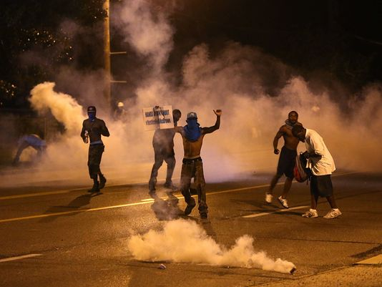

Who: Ferguson Residents
When: November 25
What: Announced that the police officer Darren Wilson would not be charged with a crime
Where: Fergusson

Extra:

Caption:

Source for quote:

